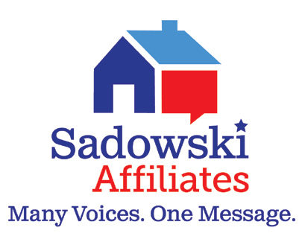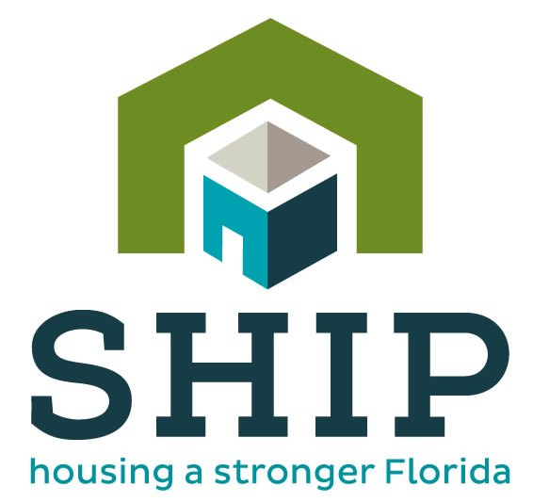

December 10, 2018

Dear {Representative/Senator},

I would like to express my gratitude and full support for SHIP funding in our community of Flagler County. The Florida local and state housing trust funds, through the SHIP and SAIL programs, are vital resources in providing our local families a safe, decent, and affordable place to live.

{Insert story or personal note}

The Sadowski Coalition and its Affiliates would appreciate any assistance in ensuring as much of these trust fund monies – full funding – are used for these Florida programs.

Please feel free to contact me at {insert contact} if I may be of further assistance or if you have any questions.

Once again thank you very much for your valuable support.

Sincerely,

{Insert name}

**Mail or E-mail to:**

**Senator Travis Hutson District Office:**

4875 Palm Coast Parkway NW, Suite 5

Palm Coast, FL 32137

Phone: (386) 446-7610

[Hutson.Travis@flsenate.gov](mailto:Hutson.Travis@flsenate.gov)

**Representative Paul Renner District Office:**

4877 Palm Coast Parkway NW, Suite 1

Palm Coast, FL 32137

Phone: (386) 446-7644

[Paul.Renner@myfloridahouse.gov](mailto:Paul.Renner@myfloridahouse.gov)